Adams Pre-K - Offline Activities/Homework
Week of | Teacher(s) | Site Name | # of Students
2/22/2021 | Sanders/Thompson | Adams Elementary | 30

Sight Word | Sight Word Book | Math Skill | ELA Skill
am, the | I am Helping | Using standard measuring tools/patterns | Black History-Poetry/Meaning of Poems

Missouri Early Learning Standards (Objectives):
Cognitive (Math & Science):
Math: Students will develop cognitive thinking. The students will use language, vocabulary, and physical representations to measure using standard materials (tape measure, rulers, yard stick, etc.) Students will begin to construct and extend size patterns;
Science: Students will increase knowledge of the physical world by making daily weather observations/predictions.
Representational (Literacy): Students will use language to communicate in a variety of ways for different purposes. Students will participate in read-alouds, focusing on pre-reading skills and answering simple comprehension questions.
Physical Development (Health/Safety): Students will develop motor skills for personally meaningful purposes by participating in fine and gross-motor skills, including writing and outdoor/motor activities.
Social Emotional/ Approaches to Learning (Social Studies): Students will cooperate and collaborate as a member of a school-learning community/name virtual/in-person classroom rules.
Essential Questions & Whole-Group
Math | ELA
- What is a pattern?  - What comes next in the pattern? What kind of pattern is it?  - How many inches tall/long is the book?  - How many inches tall/long is your foot?  - Create a AB pattern? | - What is a poem? What is poetry?  - What do you think the poet was trying to tell us?  - What words in the poem sound the same? (at the end)  - Who is ___ (poet)? What was their life like?  - Why do people enjoy hearing poetry?  - What does the poem mean?

 | Monday | Tuesday | Wednesday | Thursday | Friday-Sunday
ELA | *Read “Tails”  *Circle the sight word have when found in book  What is your favorite book?  ________________________ | *Reread “Tails”  *Circle the sight word have when found in book  Practice using have in a sentence  Read your favorite book again and answer this question:  I like this book because ________________________________________ | Reread “Tails”  sight word book  Practice writing the sight words have  Practice reading and/or writing the sight words at, it, was, in, go, are, this, can, on, come, am, the, from, said, we, to, my, will, are, me wear, for, do look is, a, with all, the, and they in your journal/notebook. | *Reread “Tails”  sight word book  Tomorrow we will let students share “Tails”  with the class  Draw a picture of your favorite part of your favorite book  Find the sight words have in yellow sight word book and complete the page by coloring the word, writing it 3 times and using or writing a sentence   | *Reread “Tails” sight word book  .  Complete all assignments from the week by Sunday
Math | Name the objects Circle what comes next in the pattern  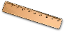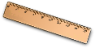  Choose what comes next in the pattern | Name the shapes and circle the missing shape in the pattern.  ___?__ | *Count the number of words in the poem you chose to recite  I have ______ words in my poem. | Create a pattern with objects from home. Take a picture and post it to Teams   | Complete all assignments from the week by Sunday
Science/  Social Studies | Continue practicing you Black History Poem! | Continue practicing you Black History Poem! | Continue practicing you Black History Poem! | Continue practicing you Black History Poem! | We will have our Black History Poetry celebration at 12 pm.
iPad | #11:30-12:00 Watch Dr. Sanders on pbs.https://video.ninenet.org/livestream/ or channel 9.2 on the antenna  Read/Listen to the assigned book: Michelle Obama on Epic    https://www.getepic.com/ | #11:30-12:00 Watch Dr. Sanders on pbs.https://video.ninenet.org/livestream/ or channel 9.2 on the antenna  Read/Listen to the assigned book: Michelle Obama on Epic  https://www.getepic.com/  *********** if you need access please contact the teacher****** | #11:30-12:00 Watch Dr. Sanders on pbs.https://video.ninenet.org/livestream/ or channel 9.2 on the antenna  Complete some activities on Smarty Ants  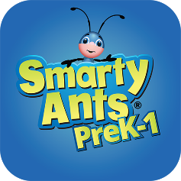 | #11:30-12:00  Watch Dr. Sanders on pbs.https://video.ninenet.org/livestream/ or channel 9.2 on the antenna  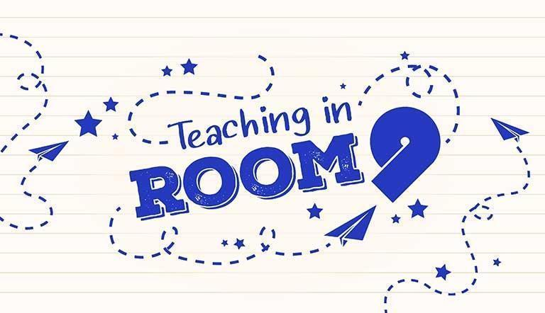  Read/Listen to the assigned book: Ella Fitzgerald on Epic  https://www.getepic.com/ | #11:30-12:00  Watch the science lesson on PBS pbs.https://video.ninenet.org/livestream/ talking about Fall or on channel 9.2 on the antenna  Complete all assignments from the week by Sunday
*Everyone completes
Other activities are optional or will be completed during virtual class

